**Proposed simulations for SPM exam**

* 6 Fishing histories with F trajectories:

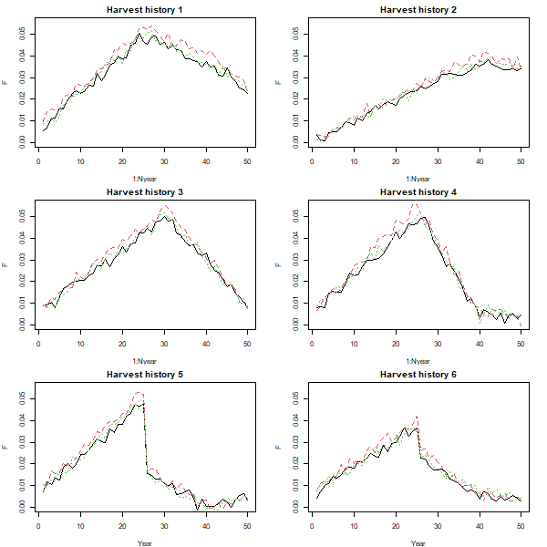

* Biomass estimates with varying Hmax display this contrast for both the true biomass and simulated (observed) estimates of biomass:

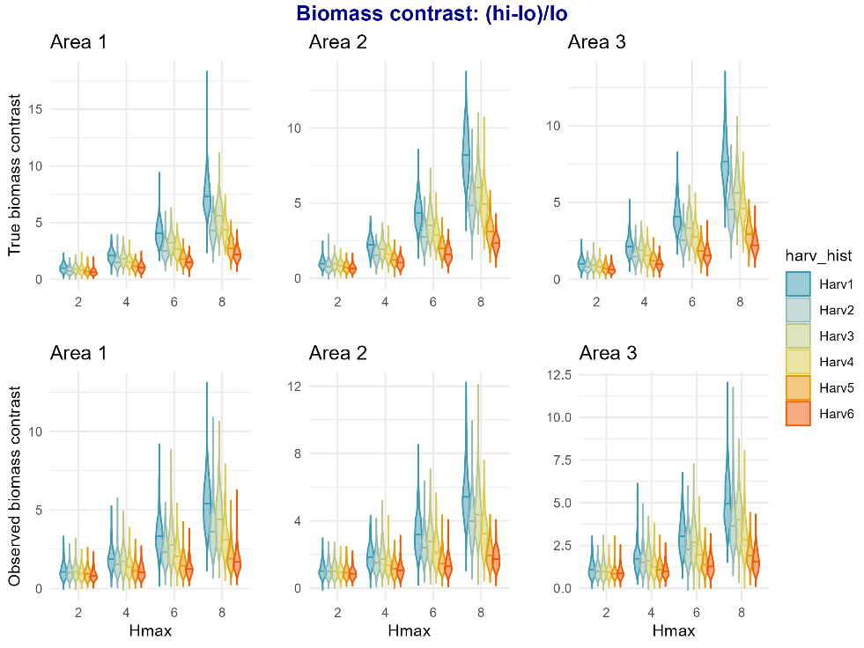

* I also calculated “rebound” which is the proportional relationship between the terminal biomass and the minimal biomass in the time series:

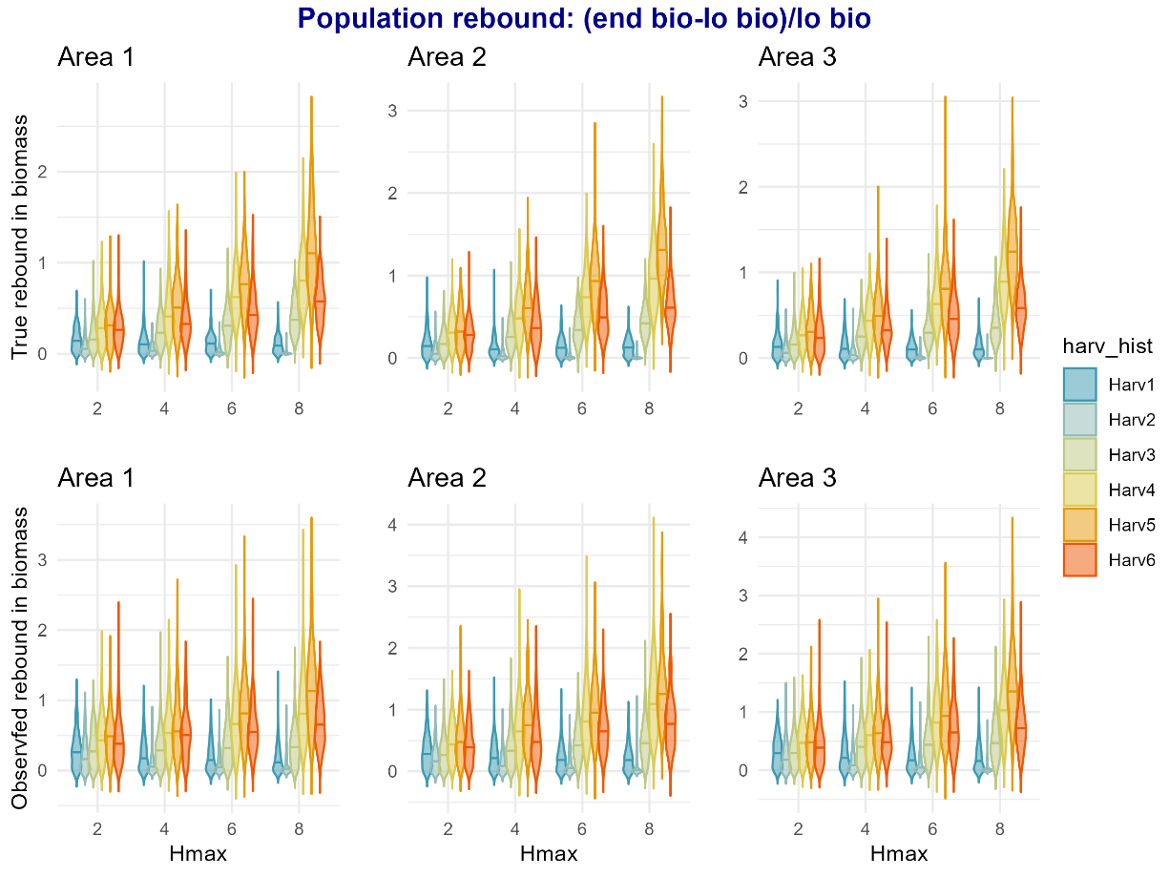

* Here are plots of simulated biomass and simulated biomass estimates (dots). Note that these simulations all start with the same K for the 3 areas.

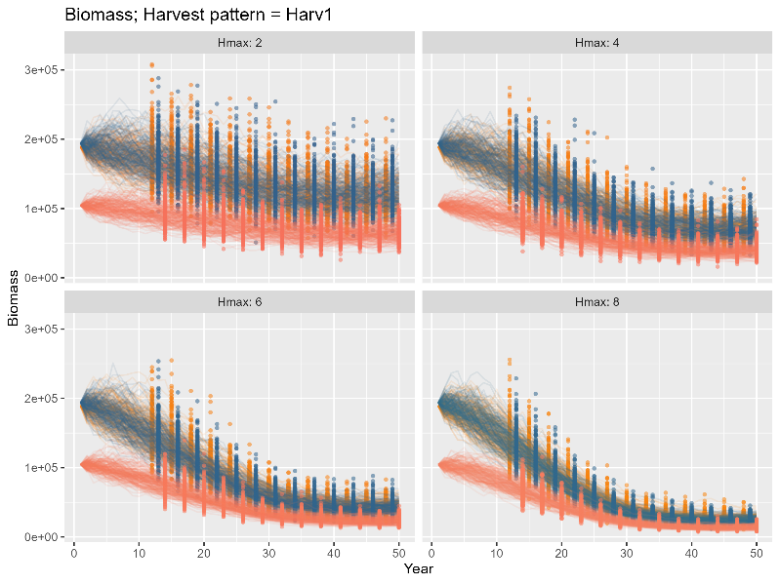

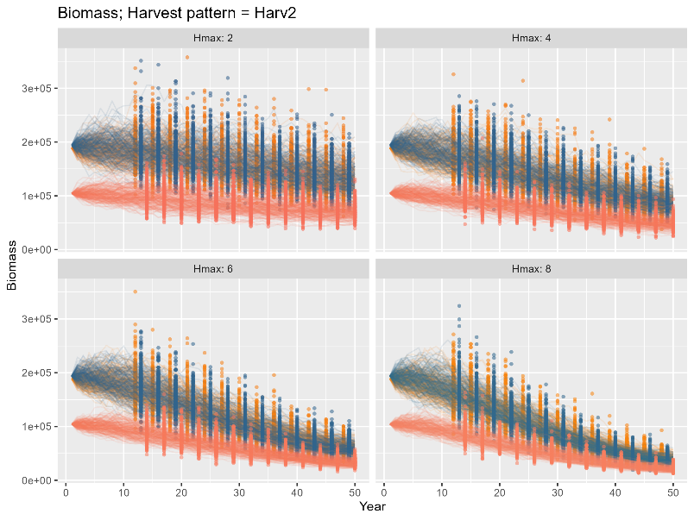

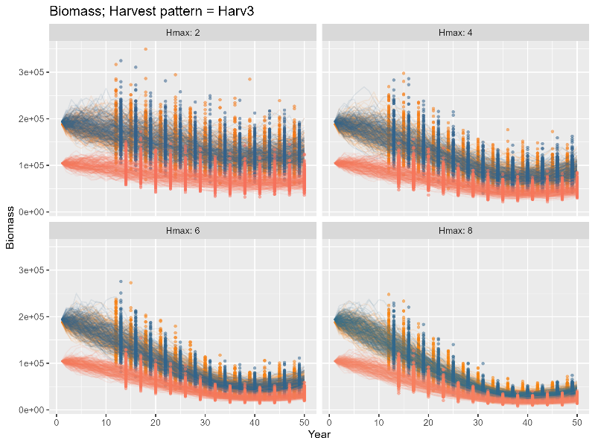

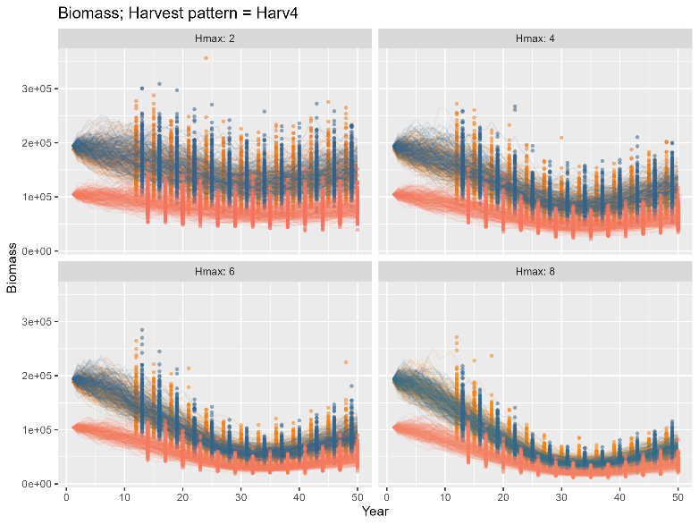

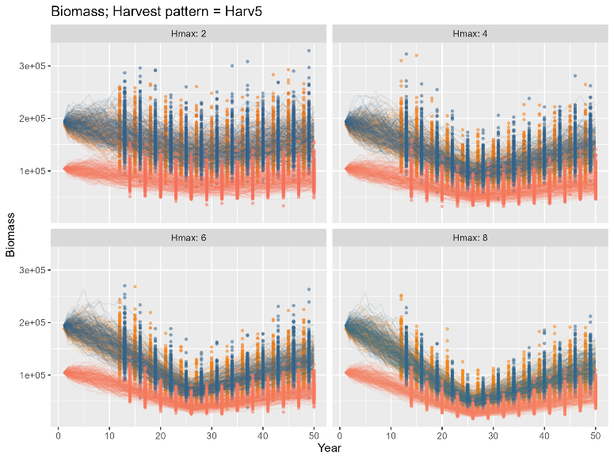

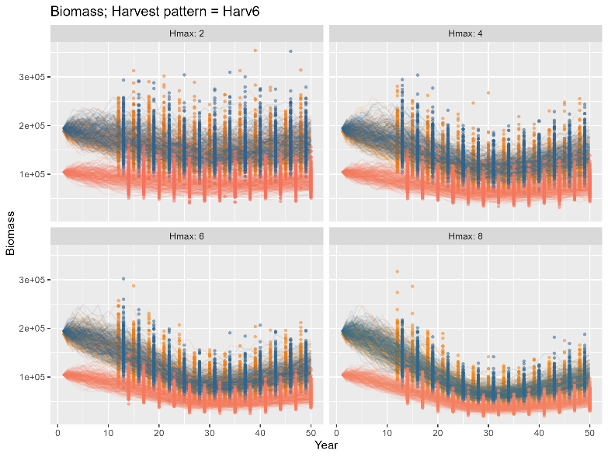

* And here is what the catch histories look like:

